COAL LAB TASK 04
roll no:24k-0954
TASK 1

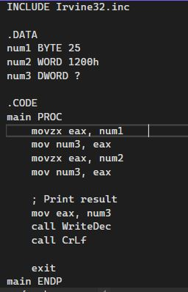
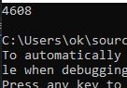

INCLUDE Irvine32.inc

.DATA
num1 BYTE 25
num2 WORD 1200h
num3 DD ?

.CODE
main PROC
movzx eax, num1
mov num3, eax
movzx eax, num2
mov num3, eax
mov eax, num3
call WriteDec
call CrLf

exit
main ENDP
END main

TASK 2

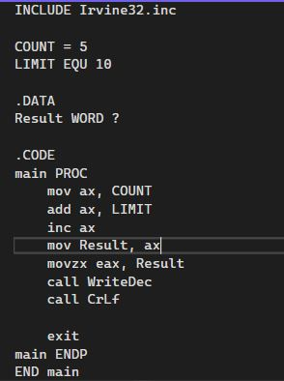
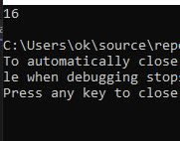

INCLUDE Irvine32.inc

COUNT = 5
LIMIT EQU 10

.DATA
Result WORD ?

.CODE
main PROC
mov ax, COUNT
add ax, LIMIT
inc ax
mov Result, ax
movzx eax, Result
call WriteDec
call CrLf

exit
main ENDP
END main

TASK 3

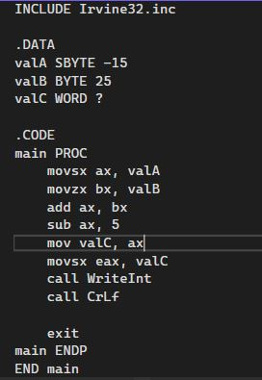
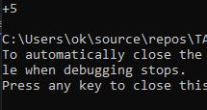
INCLUDE Irvine32.inc

.DATA
valA SBYTE -15
valB BYTE 25
valC WORD ?

.CODE
main PROC
movsx ax, valA
movzx bx, valB
add ax, bx
sub ax, 5
mov valC, ax
movsx eax, valC
call WriteInt
call CrLf

exit
main ENDP
END main

TASK 4

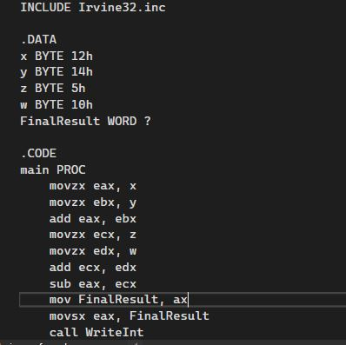
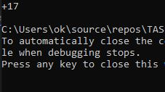
INCLUDE Irvine32.inc

.DATA
x BYTE 12h
y BYTE 14h
z BYTE 5h
w BYTE 10h
FinalResult WORD ?

.CODE
main PROC
movzx eax, x
movzx ebx, y
add eax, ebx
movzx ecx, z
movzx edx, w
add ecx, edx
sub eax, ecx
mov FinalResult, ax
movsx eax, FinalResult
call WriteInt
call CrLf

exit
main ENDP
END main

TASK 5

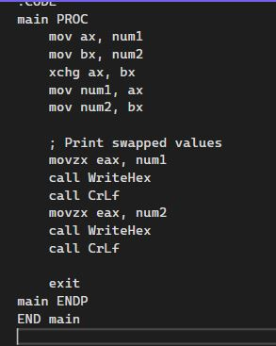
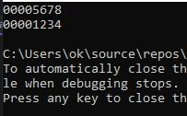
INCLUDE Irvine32.inc

.DATA
num1 WORD 1234h
num2 WORD 5678h

.CODE
main PROC
mov ax, num1
mov bx, num2
xchg ax, bx
mov num1, ax
mov num2, bx

; Print swapped values
movzx eax, num1
call WriteHex
call CrLf
movzx eax, num2
call WriteHex
call CrLf

exit
main ENDP
END main

TASK 6

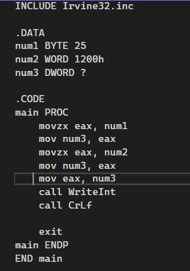
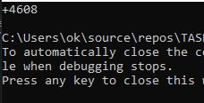
INCLUDE Irvine32.inc

.DATA
num1 BYTE 25
num2 WORD 1200h
num3 DWORD ?

.CODE
main PROC
movzx eax, num1
mov num3, eax
movzx eax, num2
mov num3, eax
mov eax, num3
call WriteInt
call CrLf

exit
main ENDP
END main

TASK 7

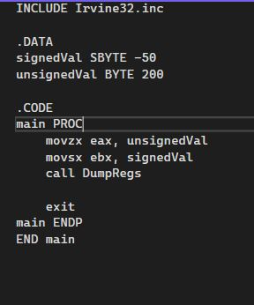
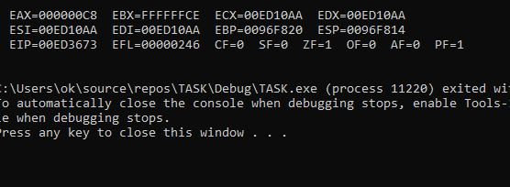
INCLUDE Irvine32.inc

.DATA
signedVal SBYTE -50
unsignedVal BYTE 200

.CODE
main PROC
movzx eax, unsignedVal
movsx ebx, signedVal
call DumpRegs

exit
main ENDP
END main

TASK 8

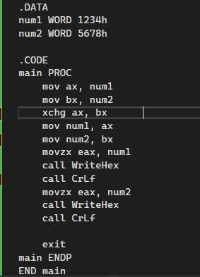
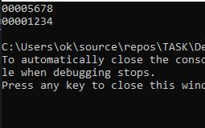
INCLUDE Irvine32.inc

.DATA
num1 WORD 1234h
num2 WORD 5678h

.CODE
main PROC
mov ax, num1
mov bx, num2
xchg ax, bx
mov num1, ax
mov num2, bx
movzx eax, num1
call WriteHex
call CrLf
movzx eax, num2
call WriteHex
call CrLf

exit
main ENDP
END main

TASK 9

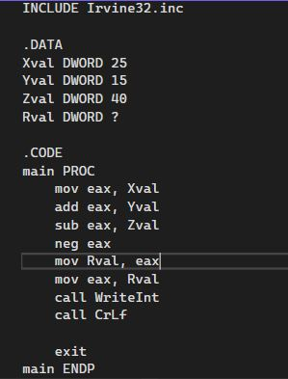
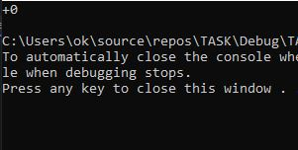
INCLUDE Irvine32.inc

.DATA
Xval DWORD 25
Yval DWORD 15
Zval DWORD 40
Rval DWORD ?

.CODE
main PROC
mov eax, Xval
add eax, Yval
sub eax, Zval
neg eax
mov Rval, eax
mov eax, Rval
call WriteInt
call CrLf

exit
main ENDP
END main

TASK 10

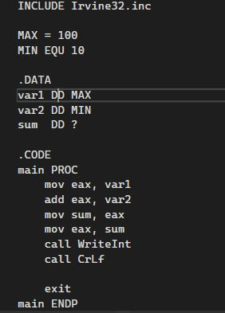
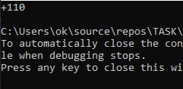

INCLUDE Irvine32.inc

MAX = 100
MIN EQU 10

.DATA
var1 DD MAX
var2 DD MIN
sum DD ?

.CODE
main PROC
mov eax, var1
add eax, var2
mov sum, eax
mov eax, sum
call WriteInt
call CrLf

exit
main ENDP
END main

